SOFTWARE ENGINEERING

M MANIDHAR - 550

03/09/23

# 1.Difference between service base and product base company?

|  |  |
| --- | --- |
| Product based company | Service based company |
| 1. A Product based company is one that has its own product to sell to consumers through the market. | 1. A Service based company is an enterprise offers services to its clients. |
| 2. Quality is main. | 2. Client is main. |
| 3. They hire only a limited no of candidates from top colleges around the world. | 3. They recruit a large no of candidates during the campus placements. |
| 4. Job security is high. | 4. Job security is low. |

## 2. List out some companies under service based and product based companies?

Product based companies:- Google, Microsoft, Amazon, Oracle, IBM, Intel.

Service based companies:- Infosys, TCS, Wipro, Cognizant, Capgemini, NIT DATA.

## **3. What is the current most popular model using by the companies?**

Waterfall model-All stages of development are sequential.

Agile

V-model

Spiral model

4/09/2023

## 4. List out the testing tools and its purpose?

**Software testing tools:-**

**Test Complete:-** It is developed by smart bear software it ensures the quality of the application without sacrificing quality or agility.

**Lambda test:-** It is a cross browser testing tool. It helps to streamline software testing process.

**Test rail:-** It is a test management tool. It helps to streamline software testing process.

**X-Ray:-** It is a test management app for jira. It helps to plan, execute and track quality assurance.

**Zephyr Scale:-** It is a test time management provides a smarter & more structured way to plan, manage and measure tests.

## **Test project:-** It is a test automation tool that allows users to create automated tested for mobile and web applications.

## 5. List out the companies works on cyber securities?

**Software Engineering:-** Build & develop systems companies cyber security.

Cisco, Sophos, Google, IBM(International Business Machine), Microsoft, Goudstrike, EMC, Dark Trace,

**Fortinet, Symantec.**

**5/09/2023**

## ****6. What are the Standalone applications and dynamic applications?****

**Standalone applications:- Stand alone applications are a type of software program that is designed to run on a single computer or local machine of the user, does not need for a server or internet connection. This application provides a no of benefits, such as offline capabilities, and greater customization(the action of modifying something to suit a particular individual or task).**

Example: Notepad, Calculator, Microsoft word, Adobe photo shop.

**Dynamic applications:-** A Dynamic web application is a type of application that can change its content, appearance, and functionality in response to user input, system events, and information. Dynamic web applications may make use of features such as load-time data-driven forms, AIAX, databases, or other services that respond to external events.

Example: Youtube’s website content has dynamically updated in response to your input.

06/09/2023

## 7. What is a client and server and their examples.

|  |  |  |
| --- | --- | --- |
| **Characteristics** | **Client** | **Server** |
| Defination | A Computer device which asks a server for services is known as a customer.  The customer is the front end element in client and server architecture which communicate, with the user and sends requests to the server. | A Server offers services to other devices connected to network.  A server primary functions include accepting and completing customer requests as well as storing and managing data. |
| Support of login | Login of single users. | Multiple users login. |
| Examples | Laptops, desktops. | Web servers, database severs and file servers. |
| Performance | The client performance is less when we compare it with the server. | The Server performance is high when we compare it with the client. |
| Functionality | It completely depends on the services of server because the server generates the services requested by the client. | It sends the requested services to the client based on their requirements. |

## 8. What are the jobs available on databases and their companies?

**Jobs Available:-** Oracle DBA, Oracle database Administration Application Lead, Senior SQL DBA, Consultant Oracle DBA, Senior Database Administrator.

**Companies:-** Airtels, Exl, Accenture, Swiggy, Oracle, firebird, SQ life, My SQL, SCV, Mango ,Texadata.

08/09/2023

## 9. Where are the google servers located?

| **Continent** | **Location** | **Geo** | **Products Location** | **Cloud Location** | **Timeline** | **Description** |
| --- | --- | --- | --- | --- | --- | --- |
| North America | [Arcola (VA), USA](https://en.wikipedia.org/wiki/Arcola,_Virginia" \o "Arcola, Virginia) | https://upload.wikimedia.org/wikipedia/commons/thumb/5/55/WMA_button2b.png/17px-WMA_button2b.png[38°56′35.99″N 77°31′27.61″W](https://geohack.toolforge.org/geohack.php?pagename=Google_data_centers&params=38_56_35.99_N_77_31_27.61_W_scale:5000_region:US) | [Loudoun County](https://www.google.com/about/datacenters/locations/loudoun-county/) | N. Virginia (us-east4) | 2017 - announced[[4]](https://en.wikipedia.org/wiki/Google_data_centers" \l "cite_note-:1-4)[[5]](https://en.wikipedia.org/wiki/Google_data_centers" \l "cite_note-:2-5) |  |
| North America | [Atlanta (GA), USA](https://en.wikipedia.org/wiki/Atlanta" \o "Atlanta) | https://upload.wikimedia.org/wikipedia/commons/thumb/5/55/WMA_button2b.png/17px-WMA_button2b.png[33°44′59.04″N 84°35′5.33″W](https://geohack.toolforge.org/geohack.php?pagename=Google_data_centers&params=33_44_59.04_N_84_35_5.33_W_scale:5000_region:US) | [Douglas County](https://www.google.com/about/datacenters/locations/douglas-county/) | - | 2003 - launched | 350 employees |
| South America | [Cerrillos, Santiago, Chile](https://en.wikipedia.org/wiki/Cerrillos,_Chile" \o "Cerrillos, Chile) | https://upload.wikimedia.org/wikipedia/commons/thumb/5/55/WMA_button2b.png/17px-WMA_button2b.png[33°31′14″S 70°43′18″W](https://geohack.toolforge.org/geohack.php?pagename=Google_data_centers&params=33.520515_S_70.721695_W_)[[6]](https://en.wikipedia.org/wiki/Google_data_centers" \l "cite_note-6) | - | Santiago (southamerica-west1) | 2020 - announced[[7]](https://en.wikipedia.org/wiki/Google_data_centers" \l "cite_note-7)  2021 - launched[[8]](https://en.wikipedia.org/wiki/Google_data_centers" \l "cite_note-8) |  |
| Asia | [Changhua County, Taiwan](https://en.wikipedia.org/wiki/Changhua_County" \o "Changhua County) | https://upload.wikimedia.org/wikipedia/commons/thumb/5/55/WMA_button2b.png/17px-WMA_button2b.png[24°08′18.6″N 120°25′32.6″E](https://geohack.toolforge.org/geohack.php?pagename=Google_data_centers&params=24_08_18.6_N_120_25_32.6_E_scale:5000) | [Changhua County](https://www.google.com/about/datacenters/locations/changhua-county/) | Taiwan  (asia-east1) | 2011 - announced  2013 - launched | 60 employees |
| North America | [Clarksville (TN), USA](https://en.wikipedia.org/wiki/Clarksville,_Tennessee" \o "Clarksville, Tennessee) | https://upload.wikimedia.org/wikipedia/commons/thumb/5/55/WMA_button2b.png/17px-WMA_button2b.png[36°37′16″N 87°15′47″W](https://geohack.toolforge.org/geohack.php?pagename=Google_data_centers&params=36.6211599_N_87.2630735_W_) | [Montgomery County](https://www.google.com/about/datacenters/locations/montgomery-county/) | - | 2015 - announced |  |
| North America | [Columbus (OH), USA](https://en.wikipedia.org/wiki/Columbus,_Ohio" \o "Columbus, Ohio) |  | - | Columbus (us-east5) | 2022 - launched[[9]](https://en.wikipedia.org/wiki/Google_data_centers" \l "cite_note-9) |  |
| North America | [Council Bluffs (IA), USA](https://en.wikipedia.org/wiki/Council_Bluffs,_Iowa" \o "Council Bluffs, Iowa) | https://upload.wikimedia.org/wikipedia/commons/thumb/5/55/WMA_button2b.png/17px-WMA_button2b.png[41°13′17.7″N 95°51′49.92″W](https://geohack.toolforge.org/geohack.php?pagename=Google_data_centers&params=41_13_17.7_N_95_51_49.92_W_scale:5000_region:US) | [Council Bluffs](https://www.google.com/about/datacenters/locations/council-bluffs/) |  | 2007 - announced  2009 - completed first phase completed  2012 and 2015 - expanded | 130 employees |

## 10. What are the different versions of Android? 12/09/2023

Nougat

Oreo

ICECREAM Sandwich

Android 5 Lollipop

Android 11

Android honeycomb honeycomb

Android eclair eclair

Android 13

Froyohttps://encrypted-tbn0.gstatic.com/images?q=tbn:ANd9GcThZ4uXqsEwDGRh7_aU7iA2kAD4A_60POSjz8iXXRk-j111jphicThFrg&s=0

Gingerbread



Jelly Bean



Lollipop

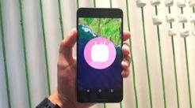

Marshmallow

https://encrypted-tbn0.gstatic.com/images?q=tbn:ANd9GcS4gWF5tKagx8stWlJA0oknDD1XRMwgwQ5kaqKPKxYeNPgRvrXRaSBCaw&s=0

Android 9 Pie

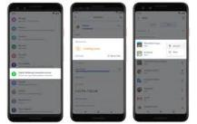

Android q beta features



Android versions pie

https://encrypted-tbn0.gstatic.com/images?q=tbn:ANd9GcTJRboLj1lre-DTkBMfiS1Ctnoky-sQ7ecUINTyLbWU8PT150dSa7WVhw&s=0

Cupcake

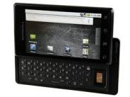

Eclair

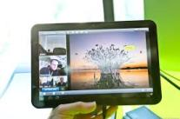

Honeycomb

https://encrypted-tbn0.gstatic.com/images?q=tbn:ANd9GcTVn2tI_23XRK6TUNDst-LUdFpjUvmQQiXKL3RHHCJo_00AYRNEqI8N2_I&s=0

Alpha



KitKat

Android 10

Android 12

## 11. What are the characteristics of software? 14/09/2023

## Top Characteristics of Software

The quality of a software product is determined by what it offers and how easily it can be used. Software is judged by different people on different grounds. Customers, for instance, want software that meets their specific needs. Similarly, developers engaged in designing, coding, and maintaining the software determine the quality of the software by assessing its internal characteristics. Let’s check them out…

### 1. Functionality

The functionality of software refers to its ability to perform and function according to design specifications. In simple terms, software systems should function correctly, i.e. perform all the functions for which they are designed.

The functions refer to the features that the end user, as well as the business, expect as basic facilities from the system. All these functions must be integrated into the system. Many software applications out there are designed for simplicity, but ultimately, the purpose of the software is to provide its users with the desired functionality.  In order to look like the best software product, it must have a clear appearance, components, and functions. However, there are also those products out there that can provide a great deal of value for your money.

### 2. Usability (User-friendly)

The user-friendliness of the software is characterized by its ease of use. In other words, learning how to use the software should require less effort or time. Navigating the software is extremely important since it helps determine the journey the user takes within the software.  This is imperative to ensure visitors remain on your website and have a positive experience, which leads to an increase in sales and brand loyalty.

An important indicator of a good piece of software is its user interface, i.e., the smooth flow of its design. A product with a great UI (User Interface) design is more likely to get noticed than one without. If a software program isn’t user-friendly, users may have trouble navigating the software and using some of its features. Software should require less time or effort to learn. Ideally, software should be easy to use even by people with no IT experience.

### 3. Efficiency

Essentially, it refers to the software’s ability to utilize human and system resources such as time, effort, CPU, memory, computation power, network bandwidth, files, databases, etc., as effectively and efficiently as possible. For a software project to succeed, efficiency is crucial. In addition to meeting the needs for which the software was made, it must also provide excellent features designed to assist users in completing their tasks faster. Software should make efficient use of storage space and execute commands according to timing requirements.

In order to be efficient, software must offer users proper value in terms of their time and cash. The market is filled with products that cater to various industries, but only a handful of products are efficient enough to benefit individuals and businesses. The medical billing software that Open Practice Solutions provides, for instance, makes billing processes much more efficient for clients than those offered by other companies.

4. Flexibility

Software Flexibility refers to the ability of the software solution to adapt to potential or future changes in its requirements. When evaluating the flexibility of software, look at how simple it is to add, modify, or remove features without interfering with the current operation.

It is essential to keep up with rapidly changing markets, technologies, and customer needs. In software development, change is inevitable; it can arise during the development process itself or as the result of future requirements. Flexibility is therefore highly valued. Consequently, any software product must be scalable, flexible, and easily adaptable to future technology. When designing or building a software product, be sure to plan for these changes that are inevitably going to occur. Loose coupling of components is the key to creating highly flexible systems.

## 12. What is metaphors 3? 21/09/2023

Metaphors are used by software developers to explain abstract or unfamiliar concepts in more concrete terms that customers & users can more easily understand.

**Common metaphors:-** viruses, bugs, crashes, fatal errors etc., Icons area great way to aid the process of understanding symbols are to assist users to grasp concepts more quickly.

## 13. Encryption:-

Adaptive Software Development has been proposed by Jim Highsmith as a technique for building complex software and system. The philosophical underpinnings of ASD focus. On human collaboration and team self organization.

## 14. What is Chartering? 22/09/2023

Chartering is an activity within the shipping industry whereby a shipowner hires out the use of their vessel to a charterer. The contract between the parties is called a charterparty. The three main types of charter are: demise charter, voyage charter, and time charter.

## 15. What is volatile requirements?

Volatile requirements These are requirements that are likely to change during the system development process or after the system has been become operational. Examples of volatile requirements are requirements resulting from government health-care policies or healthcare charging mechanisms.

## Draw the UseCase diagram for ATM machine? 4/10/2023

## [UML Use Case Diagram]

## 17. What is UML?

**UML:-**

**1. Unified Modeling Language.**

**2. UML is a way to visually represent the architecture design & implementation of complex software systems.**

**3. There are to main categories – Structure diagram, behavioral diagram.**

**4. Structure diagrams show the things in the modeled system. They show different objects in a system.**

**5. Behavioral diagram show what would happen in a system. They describe how the objects interact with each other to create a system**

**6.** Structure diagrams **– Class diagram, Component diagram, Deployment diagram, Object package profile diagram.**

**7.** Behavioral diagrams **– Use-Case diagram, Activity state machine sequence, Communication diagram etc.,**

**8. UML is way of visualizing software program using a collection of diagram.**

18.Abbrevation of CASE and examples of CASE tools? 06/10/2023

 Computer-aided software engineering (CASE) is the implementation of computer-facilitated tools and methods in software development.

There are three types of CASE tools: upper-CASE, lower-CASE, and integrated CASE tools.

## 19. What is role of software engineering in development of web apps? 09/10/2023

Application software engineers build websites and applications for end-users. You help build new features and functionality as well as update and improve existing code to keep the product running smoothly. Engineers may write front-end or back-end code — some write both. Programmer, developer, coder. These are all terms sometimes used to refer to a software engineer. Put simply, a software engineer is someone who creates computer software. But a more accurate way to think about the role is that you apply engineering principles to the software development process — designing, developing, and maintaining software. Great software engineers are exceptional problem solvers and essential partners in the [product development](https://www.aha.io/roadmapping/guide/what-is-product-development) process. While product managers lead the [product vision](https://www.aha.io/roadmapping/guide/product-strategy/what-is-product-vision) (focusing on "why" and "what" to build), software engineers bring that vision to life. You deliver the technical "how" and help set the timeline that answers "when." The field of software engineering is constantly evolving, making it an exciting and dynamic career choice. And software engineers are in high demand. In fact, the U.S. Bureau of Labor Statistics projects employment opportunities for software engineers will grow by [22 percent](https://www.bls.gov/emp/tables/occupations-most-job-growth.htm" \t "_blank) in the decade leading up to 2030.

## 20. What are the Automated estimated tools for software project cost? 10/10/2023

Estimation mistake

Parametric estimating

Analogous estimating

Expert judgment

Estimation techniques

Builder trend

Contractor Foreman

Cost of quality

Stack

Use case points

## 21. What are the tools used for scheduling task sets? 16/10/2023

Gantt chart

Wrike

Monday. pricing

Asana

Hive

Trello

Critical path method

ProofHub

Calendar

https://encrypted-tbn0.gstatic.com/licensed-image?q=tbn:ANd9GcRcEhyTIpRTI2eD5xwl099Xa2SsUpvHYkQqscLU64zvjS7zOh_ET6Kz8vkrWzFZycbLvTib&s=19

Fast tracking

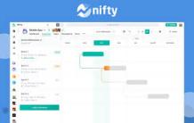

Nifty

https://encrypted-tbn0.gstatic.com/images?q=tbn:ANd9GcRXHIaUUtBKIcB4Ek4iTCemleBOdG7A-XhqFlN0-e6uGidoW3RQw7rTFg&s=0

ClickUp

https://encrypted-tbn0.gstatic.com/images?q=tbn:ANd9GcQ3oLskHxbTPFh2FHHycnj5lzKdU98LIlKNnH93CJqDMbD9y9Gohp8dUA&s=0

GanttPRO

https://encrypted-tbn0.gstatic.com/images?q=tbn:ANd9GcT_-rQ6g18ibjeyqFdCuojDuYQPEnHPanqkhAM-qPIyL7hItbhVThxY8g&s=0

Hub Planner

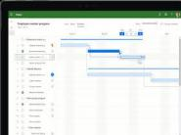

Microsoft Project

https://encrypted-tbn0.gstatic.com/images?q=tbn:ANd9GcSgRbGU9FzNHY3NtjMLlmU1LnE-aqsxlOsoK9txbWfmx4y8J7e2tRS_Hg&s=0

Simulation

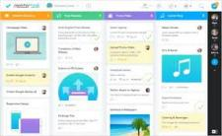

SmartTask

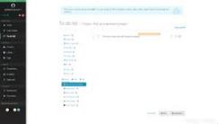

Task dependencies

https://encrypted-tbn0.gstatic.com/images?q=tbn:ANd9GcQOgEmCyeCICC_2j0T1TehJfmwvsxTmao8X5jmIq52xo2WjU7k_MtW9AA&s=0

Zoho Projects

Task list

Duration compression

Program Evaluation and Review Technique

ProjectManager

Resource leveling

## 22. What are the tools used to track the progress of project? 19/10/2023

Gantt chart

Dashboard

Jira

Time tracker

Asana

ClickUp

Monday

Todoist

Trello

Wrikehttps://encrypted-tbn0.gstatic.com/images?q=tbn:ANd9GcTTfd8UCYZHt94Ix48JcQe58WypsdRNvdRTVEpjula7PSW3usUydRqe0g&s=0

https://encrypted-tbn0.gstatic.com/images?q=tbn:ANd9GcTHB7y8l8WP0s1_0W2Jk4i2Pjk6sQbGC5kG3uRNp8u5-GBKCOadFkRgT78&s=0

Critical path analysis

https://encrypted-tbn0.gstatic.com/images?q=tbn:ANd9GcTKvUIHmHlqj5_XwYNYPfO7pRGGDjqofDW4-OwcGBxDd33UHWiefrWZtg&s=0

Microsoft

https://encrypted-tbn0.gstatic.com/images?q=tbn:ANd9GcTfXTBmMUBWUN5mrUALI-K1D6y4JNkGa7o57Z5Ix_AzYK4oJ8e86FSZZN4&s=0

Tasks

https://encrypted-tbn0.gstatic.com/images?q=tbn:ANd9GcRWjl4C5pVOLlvXKv3eKFS1teGlQRNRHx1r4W_yvjbQ1267SxEnxnkdoQ&s=0

Work breakdown structure

https://encrypted-tbn0.gstatic.com/images?q=tbn:ANd9GcT3DQEgj6X2YHr-sHlyv_DSZ9myjh8FFxhEFoPaJC5-tyTpiW4bx-oc6g&s=0

Reporting

https://encrypted-tbn0.gstatic.com/images?q=tbn:ANd9GcRELi1EQ4sz3zfqQFAxGBggajbLTv0DCHWg-XjhZtSiSraBhoP0ObOycQ&s=0

Timesheets

https://encrypted-tbn0.gstatic.com/images?q=tbn:ANd9GcQvVWI9l-umXUkDMlR3pS5CkCBzOTQkETJuUIrPo0mCJeeNb-qLdlyG_IM&s=0

Backlog

https://encrypted-tbn0.gstatic.com/images?q=tbn:ANd9GcSOSFyrXq38tSLTCQ9gS0_UX_C0ykpM8MoLQoEqdt2SYOePaqbyUOhd6g&s=0

Basecamp

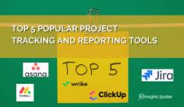

Evaluation metrics

Project management

Kanban

Project reports

Project tracking

Agile project management

## 23. What is BCWP and BCWS? 06/11/2023

**BCWP** = Budgeted Cost of Work Performed = % Complete x BAC, the value of the work or $ accomplished to date in terms of the baseline schedule, otherwise known as earned value.

**BCWS** = Budgeted Cost of Work Scheduled is the work or $ that should have been accomplished to date according to the baseline plan.

BCWP is compared to BCWS to determine if the project is behind or ahead of where is projected to be.

## 24. What are the latest versions of Python.r? 22/11/2023

**Active Phython releases:-**

3.13 prerelease 2024-10-01 (planned) 2029-10 PEP 719.

3.12 bugfix 2023-10-02 2028-10 PEP 693.

3.11 bugfix 2022-10-24 2027-10 PEP 664.

3.10 security 2021-10-04 2026-10 PEP 619.

3.9 security 2020-10-05 2025-10 PEP 596.

3.8 security 2019-10-14 2024-10 PEP 569.

## 25. What are the available software configuration management tools?

Ansible

Puppet

Chef

Salt

CFEngine

Rudder

Terraform

Juju

Octopus Deploy

https://encrypted-tbn0.gstatic.com/images?q=tbn:ANd9GcSC4I3ISjkUDYmhSBotJqBkeeAU-LLSZaqMouFeiZp5iHqdiHLcaUY77Q&s=0

Vagrant

github

## 26. Extensions for real time functions? 23/11/2023

The Realtime extension incorporates the ANSI/IEEE standards POSIX 1003.1b-1993 and POSIX 1003.1i-1995.

The Realtime extension is organized as a Feature Group within the UNIX specification, denoted by the symbol \_XOPEN\_REALTIME.

## 27. What are the various file systems? 05/12/2023

NTFS

FAT

Ext4

FAT32

exFAT

UFS

Third Extended Filesystem

Ext2

XFS

https://encrypted-tbn0.gstatic.com/images?q=tbn:ANd9GcT1kcXT5RLTWZfkyPPkhLnd-MfH6zo6D6z1hUECyZfTe6mvtPL4iJSeiQ&s=0

HFS Plus

https://encrypted-tbn0.gstatic.com/images?q=tbn:ANd9GcSV0RMXS8MplKecdggLB0HRK3wGiqV1l4iLp1wj5dczM_vtjQlTw-76A0c&s=0

Unix

https://encrypted-tbn0.gstatic.com/images?q=tbn:ANd9GcQvDhh_hAKPvfuV5zkOilHXYo7nAcQrKJ460o0Ba_SWMbpT-kEd22lAhQ&s=0

Hard disk drive

https://encrypted-tbn0.gstatic.com/images?q=tbn:ANd9GcRl30jD_fSsF0s8qrFrFZF1jwZtiwYAMEQZTS5jhYP7jZI8CxGZCihOWw&s=0

Extended file system

https://encrypted-tbn0.gstatic.com/images?q=tbn:ANd9GcQJxbajw42Rjpc3OiiLXPtkWQ93nRgnbrO-hk2c5wZVsFXQZzWFLK-70Q&s=0

VxFS

https://encrypted-tbn0.gstatic.com/images?q=tbn:ANd9GcQamOFWonCMVJClyFZ05zC-k8K50edtFtgpWfiuyJM1gM30H1cV-9Ilww&s=0

Hierarchical File System

## 28. Tools used to develop the website template?

WordPress. ...

Squarespace. ...

InVision Studio. ...

Figma. ...

Photoshop. ...

ProofHub. ...

Sketch. ...

Adobe Dreamweaver.

## 29. Draw a class diagram of ATM? 06/12/2023

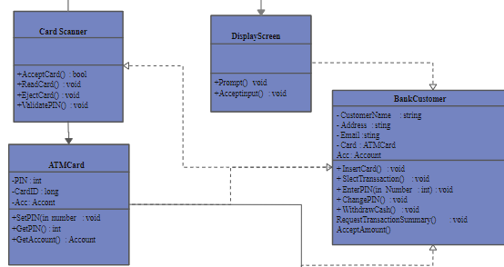

USECASE diagram for ATM Application

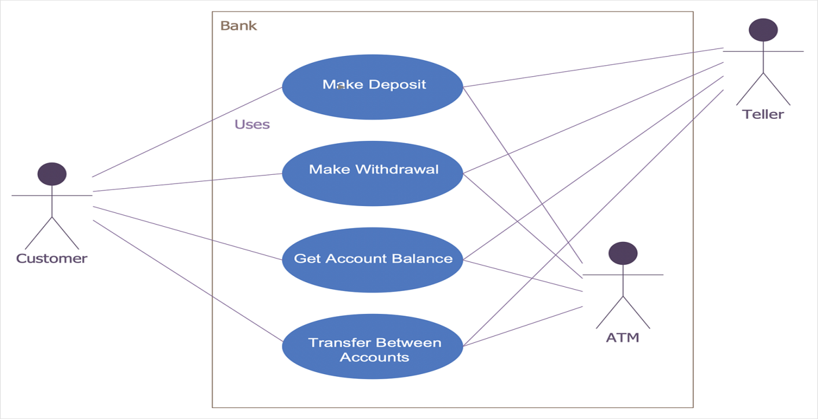

SEQUENCE diagram for ATM application

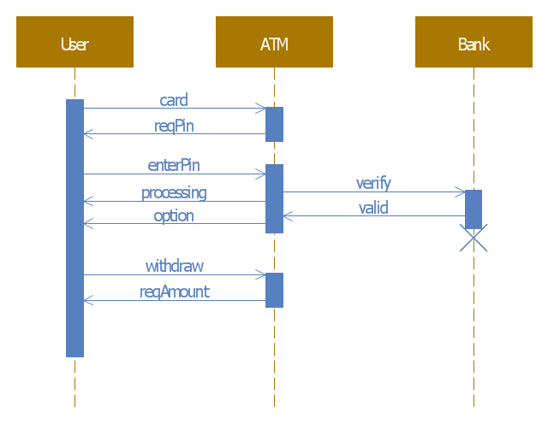

COMPONENT LEVEL design diagram for ATM Application

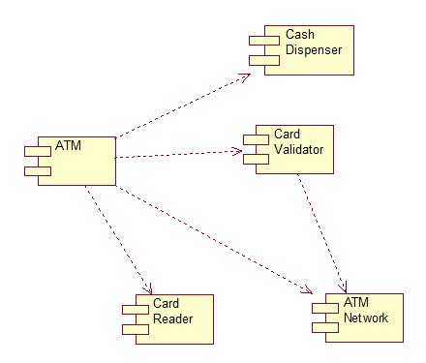

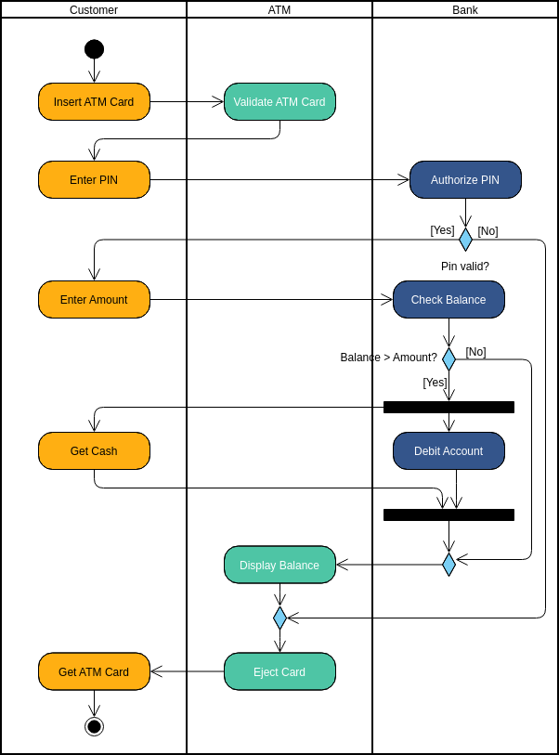

ACTIVITY diagram for ATM Application

## 30.Draw the design of the website. 11/12/2023

